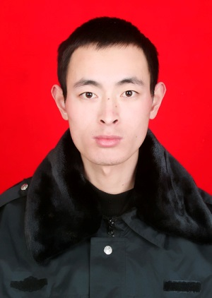

**CURRICULUM VITAE of Mr. WANG DONGYING (**[**12467251@life.hkbu.edu.hk**](mailto:12467251@life.hkbu.edu.hk)**)**

**Name: WANG, Dongying**

**Academic qualifications:**

|  |  |  |
| --- | --- | --- |
| 2006.9-2010.7 | B.S | Henan College of Traditional Chinese Medicine (TCM), Zhengzhou, China |
| 2010.9-2013.7 | M.S. | Shaanxi Normal University, Xi’an, China |
| 2013.7- | PhD. candidate | Hong Kong Baptist University, Hong Kong, China |

**Previous academic positions held:**

|  |  |  |
| --- | --- | --- |
| 2010.1-2010.6 | Intern | TCM Pharmacy of Henan Province Hospital for TCM, Zhengzhou, China. |

**Present academic position:**

2013.7- Ph. D student at School of Chinese Medicine, Hong Kong Baptist University

**Previous relevant research work:**

* Isolation of natural product chemistry
* Biological evaluation of antiviral natural products

**Representative publications in the past five years**

1. Zhao Y, Yang XB, Ren DY, **Wang DY**, Xuan Y*. Preventive Eﬀects of Jujube Polysaccharides on Fructose-induced Insulin Resistance and Dyslipidemia in Mice. *Food & Function* **2014**, 5, 1771-1778.
2. **Wang DY**, Zhao Y, Sun YF, Yang XB*. Protective Effects of Ziyang Tea Polysaccharides on CCl4-induced Oxidative Liver Damage in Mice. *Food Chemsitry* **2014**, 143: 371-378.
3. Sun YF, Yang XB*, Lu XS, **Wang DY**, Zhao Y*. Protective Effects of Keemun Black Tea Polysaccharides on Acute Carbon Tetrachloride-caused Oxidative Hepatotoxicity in Mice. *Food and Chemical Toxicology* **2013**, 58: 184-192.
4. He NW, Shi XL, Zhao Y, Tian LM, **Wang DY**, Yang XB*. The Inhibitory Effects and Molecular Mechanisms of Selenium-containing Tea Polysaccharides on Human Breast Cancer MCF-7 Cells. *Journal of Agricultural and Food Chemistry* **2013**,61:579-588.
5. **Wang DY**, Zhao Y, Jiao YD, Yu LH, Yang S, Yang XB.* Antioxidative and Hepatoprotective Effects of Polysaccharides from *Zizyphus jujube cv. Shaanbeitanzao*. *Carbohydrate Polymers* **2012**, 88: 1453-1459.
6. Wang T, Yang XB, **Wang DY**, Jiao YD, Yu LH, Zhao Y*. Analysis of Compositional Carbohydrates in Polysaccharides and Foods by Capillary Zone Electrophoresis. *Carbohydrate Polymers* **2012**, 88: 754-762.